LOAN-IN AGREEMENT
This Agreement is made between the Koninklijke Nederlandse Golf Federatie ("the Lender") and the British Golf Museum ("the Museum"), for the loan of:
I x Colf Ball and 2 x ColfCIubheads ("the Collection") by the Lender to the Museum.
The terms of the loan are as follows:
The loan of the Collection will be made to the Museum free of rental or other
- The loan will be for a period of three years effective from 3 1st May 2017 and Wilf expire on 30th May 2020.
- The Museum will be responsible for the insurance of the Collection during the loan period, while the Collection is in the Museum's care and control. Valuation of the Collection Is made by the Lender and approved by the Museum and is stated here: 30,000 Euro. This is an Agreed Value and cannot be disputed in the case of damages.
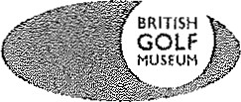
The Collection shall be insured by the Museum on a nail-to-nail basis against all risks of physical loss or damage from any cause, with the standard exclusions damage through conservation and restoration work; war or war-like action and atomic energy. Responsibility for insurance of the Collection in transit will be agreed separately between the Lender and the Museum, and subject to the relevant conditions.
In the case of loss or damage the Lender will be notified immediately. The damage will be recorded in a condition report accompanied by photographic evidence.
In the case of total loss the Agreed Value will be paid by the Museum. In the case of damages, the restoration cost as well as the depreciation will be assessed by experts named by the Lender and approved by the Museum.
- The Museum will be responsible for the security of the Collection whilst on display or in store, and agrees to safeguard the Collection under accepted conditions of control and security during the loan period. The Museum will provide security by means of locked and alarmed cases, and barriers and plinths as appropriate, in order to keep the Collection secure whilst on the premises.
- The Museum will maintain environmentally stable conditions for the Collection, protected against extremes or fluctuations of temperature, humidity, light and vibration.
- The Museum will ensure that the Collection is maintained in a suitable condition for display, and will exercise the same care with respect to the Collection on loan as it does with its own collections. Light dusting and cleaning may be carried out on the advice of conservation specialists, but no repairs, conservation or restorative work will be undertaken without the prior written permission of the Lender.
- The Museum undertakes to display or store the Collection at the British Golf Museum, Bruce Embankment, St Andrews KY 16 9AB. The Collection may only be removed outwith the Museum following the prior written permission of the Lender except in the case of an emergency.
The Museum has the sole right to determine if the Collection will be placed on display and how the Collection will be displayed. The Lender loans the Collection with the understanding that the Lender cannot restrict, command or otherwise determine the manner in which the Museum will interpret the Collection, its use or and its placement. Unless instructed otherwise, when the
Collection is on display, any captioning will include the credit "Loaned by the Royal Netherlands Golf Federation"
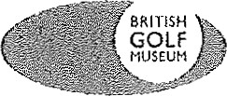
- The Museum reserves the right to take and use pictures or reproductions of the Collection for the purposes of its own literature, cataloguing non-commercial educational uses and publicity.
- At the end of the loan period this Agreement may be renewed by mutual consent.
l l . If the ownership of the Collection is transferred by the Lender during the duration of this Agreement, this Agreement shall be binding on the Lender's successor or assignees whosoever. At the termination of this Agreement or the extension thereof, or in the event of the Museum being liquidated or its assets sold within the period of the loan, the Collection will immediately revert to the Lender.

210
Signed for The British Golf Museum, this .
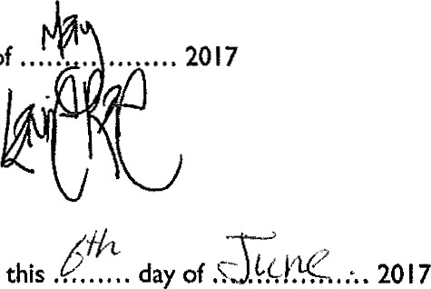
Signed for the Koninklijke Nederlandse Golf Federatie this . . .. . .
.
day
of
